Halves of Cakes Lesson
Grade: 1st Grade |  |  | Subject: Math
Materials: Worksheets, crayons, Are the Circles Cut in Half video |  |  | Technology Needed: Active Board, Projector
Instructional Strategies:  ð Direct instruction  ð Guided practice  ð Socratic Seminar  ð Learning Centers  ð Lecture  ð Technology integration  ð Other (list) |  | ð Peer teaching/collaboration/  cooperative learning  ð Visuals/Graphic organizers  ð PBL  ð Discussion/Debate  ð Modeling | Guided Practices and Concrete Application:
 |  |  | ð Large group activity  ð Independent activity  ð Pairing/collaboration  ð Simulations/Scenarios  ð Other (list)  Explain:  Students will independently work on the worksheet given. | ð Hands-on  ðTechnology integration  ð Imitation/Repeat/Mimic
Standard(s)  1.G.3 “Partition circles and rectangles into two equal shares.  Describe the shares using the word halves, and use the phrase half of. Describe the whole as two of the shares.” |  |  | Differentiation  Below Proficiency: Focus on equal parts  Above Proficiency: Provide different shapes to divide in half.  Approaching/Emerging Proficiency: Focus on dividing wholes into equal shares.  Modalities/Learning Preferences: Physical, verbal, logical
Objective(s)
By the end of the lesson, students will demonstrate their understanding of the terms halves, and half of, by dividing a circle into two equal shares.

Bloom’s Taxonomy Cognitive Level: Demonstrate
Classroom Management- (grouping(s), movement/transitions, etc.)  - Students will be in whole group at the carpet. No supplies are needed.  - Say “5,4,3,2,1” if students are talking to others when you are trying to teach. They will say “time for talking to be done.”  - Use popsicle sticks (has the students names on them) when needing a volunteer to complete a task. |  |  | Behavior Expectations- (systems, strategies, procedures specific to the lesson, rules and expectations, etc.)  Whole group expectations: Criss-cross legs, Sits on their assigned carpet square spot.
Minutes | Procedures
5 | Set-up/Prep:  - Print off copies of “Making Cakes” Worksheet for each student.  - Have the overhead projector ready to go  - Cut the “Quick Flash Cards” Worksheet on the dotted lines.
5 | Engage: (opening activity/ anticipatory Set – access prior learning / stimulate interest /generate questions, etc.)  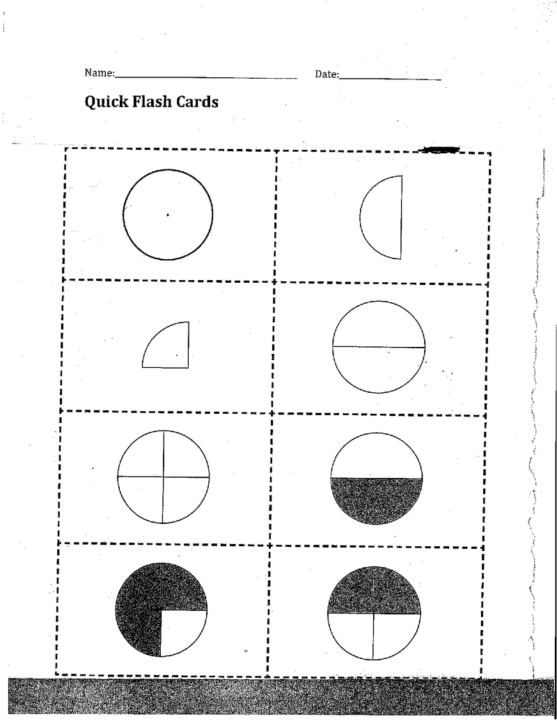  - Tell the students, "I am going to flash a few different shapes. I will flash it once for about 3 seconds. Your job will be to draw and describe the shape. I will then flash it again so that you can check your work. When you are finished, I will ask people to describe what they saw and drew."  - Using the Quick Flash Cards (see section resource), flash the 1st image using the projector..  - Display the image for 3 seconds and then cover it up. Ask the students to draw and describe the shape.  - Then, flash the same shape again for another 2 seconds to allow them to check their work.  - Finally, leave the image showing as students describe the shape they drew.  - Repeat this for the 2nd and 3rd shapes.
15 | Explain: (concepts, procedures, vocabulary, etc.)  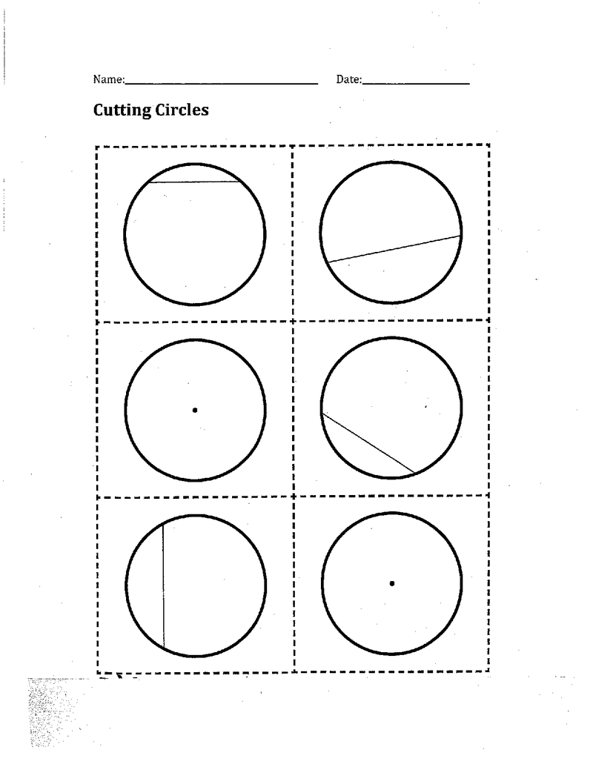  - "We are going to spend the next few days talking about fractions and what it means to break things up into equal parts. During our measuring unit, some of you were using the term 1/2. This is an example of a fraction and it is called one half. What else do people know about halves?" Turn and talk to a neighbor and see what they know about halves.  - Get students attention by saying “5, 4, 3, 2, 1” - They will say “Time for talking to be done.” Wait until all students are criss cross applesauce and are paying attention. What did you and your neighbor come up with for measuring equal parts? (Answers vary).  - You may have talked about 2 halves of a game, your favorite show is a half hour long, you shared something by splitting it into half, etc.  - As we look at the examples shown (show quick flash cards worksheet under overhead), each represents a whole divided into 2 equal parts.  - "Let's pretend that I want to share a cake with my best friend. In order to do this, I will have to cut it in half. I want to make sure that we both get an equal share. Let's take a look at this first cake/circle (I show a full circle from the Cutting Circles resource). I want you to think about where I would draw a line to cut this cake in half?" There is a video in the resource section called Are the Circles Cut in Half? that models this part of the lesson. Show the video.  - Draw a line through the circle that clearly doesn't cut it into two equal parts.  - "Is this cake cut in half? How do you know? How would you fix it?" (Answers vary).  - Then show them more of the circles from the resource asking the same questions as above.  - Draw a popsicle stick and ask for the student to come up and draw a line through the last blank circle.  - Did he/she do it correctly? How do you know? Answers vary.  - Now that we have a cake that is cut in half, I want to show you how to label each half."  - Then model the 1/2 recording. It is important that the fraction be written 1 over 2 and not with a slanted line. Using a slanted line is not an accurate recording because it indicates a ratio rather than a fraction.  - Notice that the smaller number is on top and the larger number is on the bottom.  - Next, we will be creating our own cakes using the worksheet I will be handing out.  - Hand out Making Cakes Worksheet.
20 | Explore: (independent, concrete practice/application with relevant learning task -connections from content to real-life experiences, reflective questions- probing or clarifying questions)  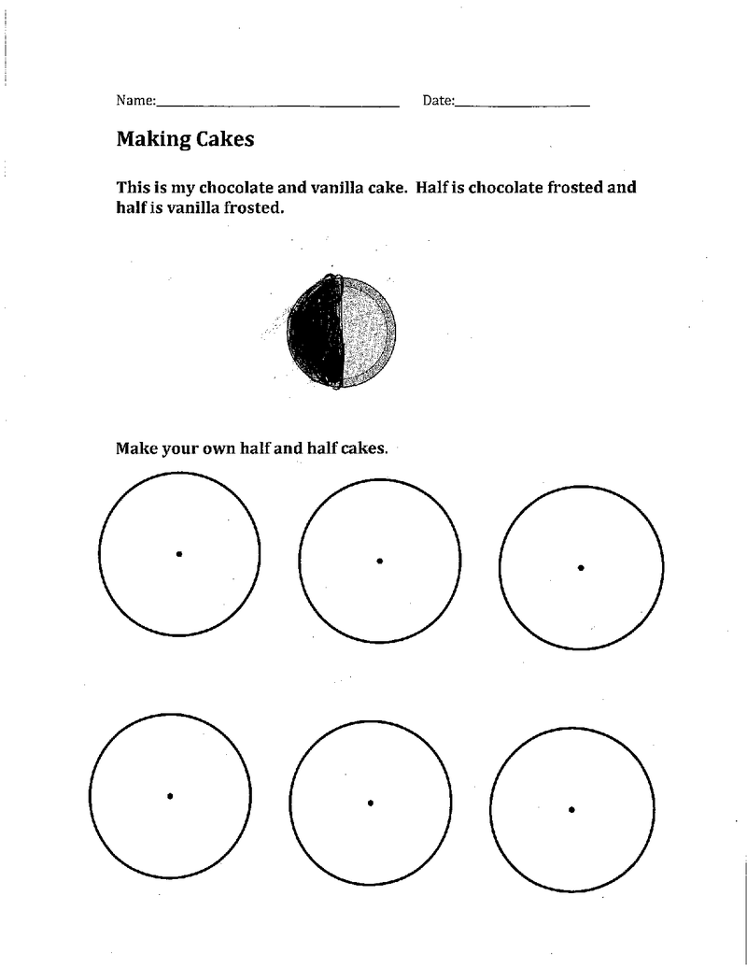  - “I love cakes. I make a cake every Saturday. I need one cake to feed my family dessert."  - Look at the sheet I just handed out labeled Making Cakes.  - "Sometimes we disagree because I want chocolate frosting and my sister wants vanilla. However, our baker is very kind and will frost half the cake with chocolate and half with vanilla."  - Then show them the example that is at the top of the paper. (Put under overhead and point your finger to the top part)  - "You will now be the bakers and create your own half and half cakes. Half of your cake will be frosted one way and the other half will be frosted another. You can use any flavors you like.  - When I say go, I want you to grab out your your crayons and colored pencils. Do not use markers. When you are done I am going to come around and check to see that there are no markers. Go! Check to see that there are no markers on the desks.  - If needed, say “5,4, 3, 2,1” to get the students attention. Explain “You will need to make sure that you label each half."  - "Before you start, I want to look at a few ways that a cake can be cut in half. Let's look at the easel (see picture in section resource titled, Ways of Cutting a Cake)."  - Then fold a paper circle in half and show them what it looks like with the line going through the middle and draw that line through the center of one of the circles on the easel.  - Turn the paper circle and model (on the easel) where the line is cutting the circle now. Again, model it on the easel. Make sure that the students see that even though the line is in different places, there are still two equal parts.  - Give me a fist to chest thumbs up or down if you think you are able to divide the cake into half.  - Ask students to draw a line down the middle of each “cake” on their page to divide it into two halves.  - Give them time to color and decorate their cakes.  - Give a 2- minute warning before transitioning into the exit slip (see below).
5 | Review (wrap up and transition to next activity):  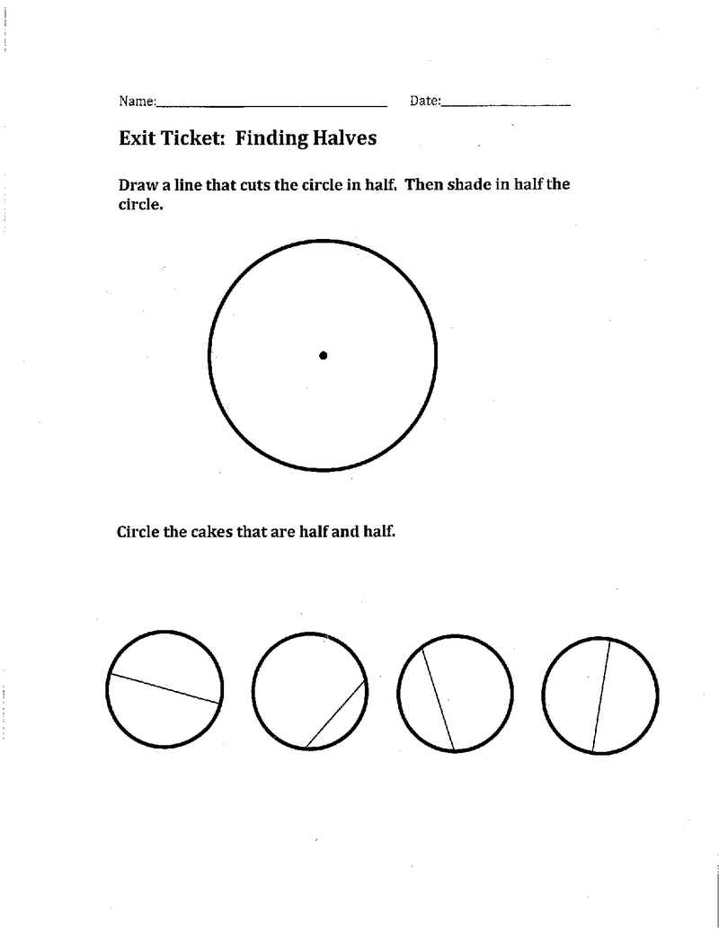  - From today’s lesson, I am going to have you fill out an exit ticket. This will allow me to see if you understand what we covered today.  - Hand out an exit ticket and allow for students to complete the worksheet.  - This will allow me to informally assess how students are doing with the half concept.
Formative Assessment: (linked to objectives)  Progress monitoring throughout lesson  - Thumbs up or down if you understand the material.  Using the circle “cake”, students will draw a line down the center and color in each half to represent that they made half of the cake one flavor and the other half a different flavor.  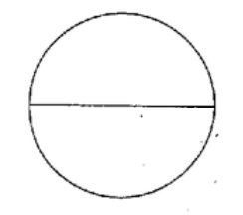  Consideration for Back-up Plan:  Have students draw circles on a plain sheet of paper and have them do the following steps as above under the “explore” part of the lesson. |  |  | Summative Assessment (linked back to objectives)  End of lesson:  Students will show that they know how to divide a circle into two equal halves by drawing a line down the center of the circle on the exit ticket.  If applicable- overall unit, chapter, concept, etc.:  At the end of the unit, students will be able to display their understanding that shapes can be split into two halves by drawing a line down the center of the shape.
Reflection (What went well? What did the students learn? How do you know? What changes would you make?):

Not Available

