University of Mary Division of
Education Instructional Sequence
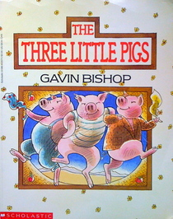
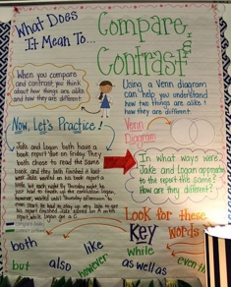
Grade Level: 3rd
Subject(s) Area: Language Arts
Materials Needed:
- Compare and Contrast Anchor Chart
- The Three Little Pigs by Gavin Bishop
Standards:
- SL 3.1 Engage effectively in a range of collaborative discussions (one-on-one, in groups, and teacher-led) with diverse partners on grade 3 topics and texts, building on others’ ideas and expressing their own clearly.
  - SL 3.1b: Follow agreed-upon rules for discussions (e.g., gaining the floor in respectful ways, listening to others with care, speaking one at a time about the topics and texts under discussion).
Objectives:
- Students will identify and use the signal language for comparing and contrasting.
- Students will identify comparisons and contrasts in text.
Learning Activities:
- Ask students to think of ways that myself and Mrs. Eder are similar and raise hand to share
- Ask students to think of ways that myself and Mrs. Eder are different and raise hand to share
- Tell students, “By thinking of ways that Mrs. Eder and I are similar and different, we are comparing and contrasting.”
- Introduce compare and contrast anchor chart
- Go over compare and contrast definitions
- Explain Venn Diagram
  - Ask students to turn to their learning partner to discuss if they have used a Venn diagram before. If yes, when and why?
- Point out comparison and contrast key words
- Read text on anchor chart out loud
- Ask learning partners to identify similarities, then differences in the text
- Ask students to think about the characters, setting, problem, etc. during the read aloud
- Read The Three Little Pigs, using metacognitive strategy determine text importance.
- Record important information from the book on large paper.
- Tell students they can compare and contrast characters in books they are reading or books they have already read during Daily 5 to understand them better
- Record Daily 5 choice in notebook
Assessment:
- Take note of which students can or cannot contribute to the discussion of the compare and contrast poster
  - Use learning partners and call on them with popsicle sticks to see who understand the concepts.
Reflection:
- No matter what I do, teaching based on set lesson plans and standards does not seem natural at all.
- I liked how they received comparing and contrasting Mrs. Eder and I at the beginning. That helped them engage right away.
- Also, its hard for me to use specific metacognitive strategies while reading picture books. I understand using the general strategies while reading the book, but doing specific ones seems so awkward to me.
- They received the concept quite well and had already used Venn diagrams.
- I was surprised with their little struggles when comparing and contrasting the little passage I had written.
  - Prompting helped well with some, but really had to help one girl.
- I have to edit my lesson plan tomorrow, changing the book as they already read two I was going to use.
- Next time, I will put questions on sticky notes stuck to the book so I know exactly what to say when reading, as it seemed very rocky.

