Grade: 1 |  |  | Subject: Art – Wax Resist
Materials: Leaves, white paper, crayons, water colors, paint brushes |  |  | Technology Needed: Laptop, ActivBoard, Ladibug Camera
Instructional Strategies:  - Direct instruction  - Guided practice  - Socratic Seminar  - Learning Centers  - Lecture  - Technology integration  - Other (list) |  | - Peer teaching/collaboration/  cooperative learning  - Visuals/Graphic organizers  - PBL  - Discussion/Debate  - Modeling | Guided Practices and Concrete Application:
 |  |  | - Large group activity  - Independent activity  - Pairing/collaboration  - Simulations/Scenarios  - Other (list)  Explain: | - Hands-on  - Technology integration  - Imitation/Repeat/Mimic
Standard(s)  4.1.2 Know the different techniques* used to create* visual art. |  |  | Differentiation  Below Proficiency: Tape down the leaves and paper while rubbing the leaves with crayon  Above Proficiency: Create a design with the leaves  Approaching/Emerging Proficiency: Create visual art using wet on wax  Modalities/Learning Preferences: Tactile
Objective(s)
By the end of the lesson, students will create visual art using wet on wax technique with crayons and water colors.

Bloom’s Taxonomy Cognitive Level: create
Classroom Management- (grouping(s), movement/transitions, etc.)  During the video, children will sit at assigned star spots  Students will sit/stand at assigned desks  Designate certain students to pass out supplies |  |  | Behavior Expectations- (systems, strategies, procedures specific to the lesson, rules and expectations, etc.)
Minutes | Procedures
5 | Set-up/Prep:  - Get video ready  - Set out crayons  - Get 20 sheets of white paper  - Put 7-10 leaves in a container for each pod of tables (4)
3 | Engage: (opening activity/ anticipatory Set – access prior learning / stimulate interest /generate questions, etc.)  - Tell the students we will be doing an art project about fall  - Play “Autumn Leaves are Falling Down” video: https://www.youtube.com/watch?v=CyJIfdA71Lc
5 | Explain: (concepts, procedures, vocabulary, etc.)  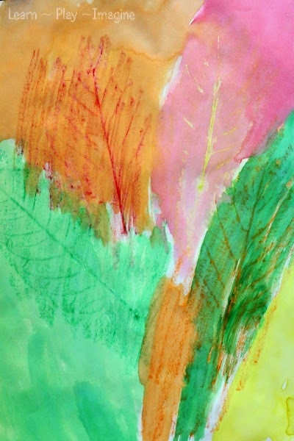  - Tell the students they will use leaves to create an art project.  - Explain that they will put the leaf under a piece of paper and hold it in place securely then rub a crayon over the leaf.  - Ask students what colors they should make their leaves (green, orange, yellow, brown)  - Then, they will use watercolors to paint over the rubbed leaves.  - Ask if anyone knows what will happen when they paint water color on the crayon?  - Explain that the crayon is made of wax, and wax will resist the water color, or crayon will repel the water color away from it  - Ask 2 students to hand out paper, 1 student to hand out leaves, and 2 students to hand out crayons (all on Mrs. Brilz’s desk).  - Dismiss students back to their desks
20 | Explore: (independent, concreate practice/application with relevant learning task –connections from content to real-life experiences, reflective questions- probing or clarifying questions)  - Take students through the project step-by-step by modeling it on the ActivBoard.  - Have students take one leaf (they will have the opportunity to use more than one leaf) and put it under their white piece of paper  - Demonstrate using the flat edge of the crayon to rub on the leaf  - If students have difficulty keeping the leaf in place, have scotch tape ready to tape the stem in place.  - Have students repeat rubbing the leaves with crayon until their page is filled (or they are satisfied)  - When everyone is finished at their table, have them put crayons away and wait for further instructions.  - Have students from the finished table(s) hand out watercolors  - Demonstrate how to use watercolors to paint over the crayon.  - Allow students to paint over their crayon leaves.
2 | Review (wrap up and transition to next activity):  - When students finish, they put their picture on the ledge to dry and clean up their desks and all supplies back to Mrs. Brilz’s desk.  - Review why the crayon will resist water.  - Turn them over to Mrs. Brilz when they are all finished and cleaned up.
Formative Assessment: (linked to objectives)  Progress monitoring throughout lesson- clarifying questions, check-  in strategies, etc.  After demonstrating, move around the classroom to assist students and ask them why they did the design or chose the colors they did.  Consideration for Back-up Plan: Tape the stem to the desk when rubbing the leaves. If they cannot handle both steps, just do the rubbing of the leaves. Do random leaves once and have them make a design on the second paper. |  |  | Summative Assessment (linked back to objectives)  End of lesson: Students will create visual art using wet on wax technique with crayons and water colors and turn in their paper before hanging it up.  If applicable- overall unit, chapter, concept, etc.: None
Reflection (What went well? What did the students learn? How do you know? What changes would you make?):
I had to be very flexible for this lesson. We changed around parts of this lesson beforehand and as we went along. I ended up changing the video from cheesy YouTube video about leaves to using an information page about fall and a video of a tree changing throughout the seasons (focused on fall) from PebbleGo. Mrs. Brilz wanted the students to get outside and move, so after the video, the students got a plastic bag and we walked outside to the other side of the faculty parking lot. Then, I explained what kind of leaves they should collect (not brown and crumbly but yellow/green and veiny). Then, I had them collect 10 leaves each which took about 3 minutes. Then, we walked back inside, put the leaves on their desks, and sat down in their star spots. Then, I explained and demonstrated the art project. I was surprised that most of the students had never used crayon and watercolors before and a few students said they had not used watercolors before. The camera really helped to show them what I was doing so everyone could see - Emelio was amazed that I was doing it and it just showed up on the screen! However, the camera seemed like an off-brand as the picture did not get completely clear, even when I focused it. I wonder if it had an accompanying light to shine on the paper it would show up better. However, I got it from the library media specialist and it was brand new, so it was for sure not a use issue. I should have planned out the process of handing out materials and dismissing the students back to their desks. I had talked to students beforehand to help pass out items, but I must have not been completely clear. Next time, I think it would work better to have one person from each pod get materials for their whole pod. For example, one student would get 4 paint brushes, another would get 2 watercolor pallets, another would get two cups of water and fill them, and the final student would get paper. Two students would tape down the stems, but I only had Gabby and one roll of scotch tape. All students seemed engaged with the lesson, but I wish I had an assistant during the lesson. Mrs. Brilz was on her computer the whole time and I felt that I was stretching myself thin. Students wanted me to help peel the wrapper off their crayons, find the leaf under their paper, rub the crayon on, etc. I was constantly doing something. Several students had to start over because they did not understand and messed up. I felt like I spent my whole time on one side of the classroom and I wish someone could have helped me on the other side. I plan on pasting the pictures on construction paper and hanging them up in the hallway. If Mrs. Brilz okays it, I would like to have creating another leaf rubbing during free choice Friday.

