Grade: 1 |  |  | Subject: Math
Materials: Worksheets from Student Activity Book, manipulatives (number line, blocks, etc.) |  |  | Technology Needed: ActivBoard, laptop, math curriculum program for “Start With/Get To: Get to 1”
Instructional Strategies:  - Direct instruction  - Guided practice  - Socratic Seminar  - Learning Centers  - Lecture  - Technology integration  - Other (list) |  | - Peer teaching/collaboration/  cooperative learning  - Visuals/Graphic organizers  - PBL  - Discussion/Debate  - Modeling | Guided Practices and Concrete Application:
 |  |  | - Large group activity  - Independent activity  - Pairing/collaboration  - Simulations/Scenarios  - Other (list)  Explain: | - Hands-on  - Technology integration  - Imitation/Repeat/Mimic
Standard(s)  1.OA.1: Use strategies to add and subtract within 20 to solve word problems involving situations of adding to, taking from, putting together, taking apart, and comparing, with unknowns in all positions. |  |  | Differentiation  Below Proficiency: Reread the problem with students who are having difficulty getting started and encourage them to tell the story in their own words. Some may need help directly modeling what is happening in the situation by using counters. Focus on mastering one strategy to solve the word problems.  Above Proficiency: Students can show a second way to find the answer or solve the related story problem on Student Activity Book page 40. Challenge them to think about whether and how the first problem can help them solve the second problem.  Approaching/Emerging Proficiency: Utilize strategies to subtract within 20 to solve word problems.  Modalities/Learning Preferences: Auditory, visual, tactile
Objective(s)
By the end of the lesson, students will utilize various strategies to subtract within 20 to solve word problems.

Bloom’s Taxonomy Cognitive Level: Utilize
Classroom Management- (grouping(s), movement/transitions, etc.)  - Students will be in whole group at the carpet. No supplies are needed.  - Say “5,4,3,2,1” if students are talking to others when you are trying to teach. They will say “time for talking to be done.”  - Use struggling students’ names and objects to write the story problems. |  |  | Behavior Expectations- (systems, strategies, procedures specific to the lesson, rules and expectations, etc.)  Whole group expectations: Criss-cross legs, sit on their assigned star spot on carpet  Worksheet expectations: work at desk primarily, but can move to a spot in the room where they work better
Minutes | Procedures
2 | Set-up/Prep:  - Set up math program on active board.
5 | Engage: (opening activity/ anticipatory Set – access prior learning / stimulate interest /generate questions, etc.)  - Display the Teacher Presentation (or use “Start With/Get To Cards)  - Choose with a start with number  - Ask students to find and mark the number on the class number line  - As a class, count together, from this number backward to 1  - Use the number line to keep track of the numbers as you count  - Choose several start with numbers and repeat as time permits
10 | Explain: (concepts, procedures, vocabulary, etc.)  - Open Active Inspire to write stories using struggling students’ names and chosen objects for students to retell and solve as a whole group  - Read the story outload. Encourage students to visualize what is happening in the story  - Ask several students to retell 1 fact from the story  - Ask whether the ending amount is more or less than the initial amount (to determine addition or subtraction)  - Write out the equation in the word problem  - Have students solve the problem and share their strategies  - As you discuss students’ strategies, describe and model their methods, connecting these methods to the context of the problem. Encourage students to compare their strategies.
30 | Explore: (independent, concreate practice/application with relevant learning task -connections from content to real-life experiences, reflective questions- probing or clarifying questions)  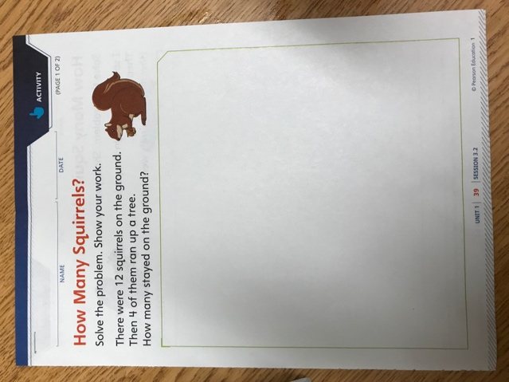  - Read the problem on Student Activity Book page 39 aloud:  - “There were 12 squirrels on the ground. Then 4 of them ran up the tree. How many squirrels were left on the ground?”  - Ask two or three students to put the story in their own words. Keep the emphasis on retelling the story and not finding the answer.  - When you are satisfied that the students have a good grasp of the story, explain that students are to solve the problem and show their work. While they should work individually, encourage them to discuss their strategies with one another.  - Hand out the worksheet and have students return to their desks to complete it.  - Informal assessment: Observing students at work  - How to students make sense of the problem? Do they identify the quantities involved and relate them to the story? Do they understand what they are trying to figure out (the number of squirrels left on the ground)?  - How do students solve the problem? Can they explain their strategies? Do they get the right answer?  - How do students record their work? Do they use numbers? Pictures? Words? Equations? Does their work accurately reflect the strategy they used to solve the problem?  - Make note of various approaches you see so that you can encourage students with different approaches to share their work with the class at the end of the session.  - After about 5 minutes (more or less depending on student progress), call them back to their star spots.  - Ask several volunteers to explain how they solved the problem. Have cubes available for students to demonstrate their strategies.  - Record each different method on the ActivBoard, basking your recoding on the student’s approach  - Once you have a range of strategies, ask students to look at their papers and decide which of the strategies that you recorded is closest to their own. Ask for a show of hands for each approach.  - End by spending some time talking about how the equation 12 – 4 = _____ represents what the problem is asking, and about what the number(s) and symbols in the equation represent/mean. Fill in the now agreed upon answer.  - “We agree that if there are 12 squirrels, and 4 run away, 8 are left. Mathematicians have a way of writing down what happened in this kind of a problem. This equation says that 12 minus 4 equals 8. Instead of writing words, they use this subtraction sign, which is also called a minus sign to show that – in this case – one amount is being taken away from another amount. Which amount did we take away in this problem? What did we take it away from?”  - End the discussion by reinforcing the meaning of the equal sign as a way to show that what’s on one side is equivalent to what’s on the other side.
15 | Review (wrap up and transition to next activity):  - 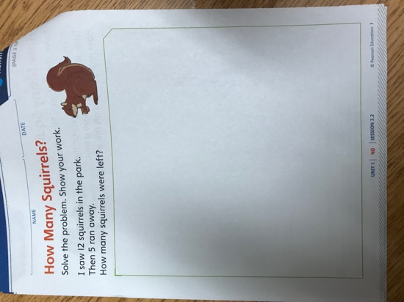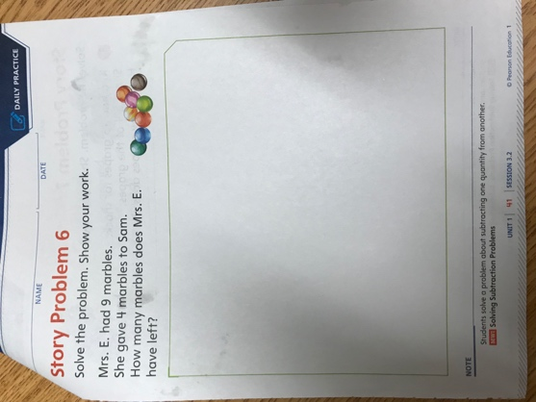  - For reinforcement of this unit’s content, students complete Student Activity Book page 41.  - At 12:55, have students turn in the worksheet to Mrs. Brilz’s desk (completed or in completed), as long as they were working the entire time on it.  - After turning in their assignments, students will line up by the door on their designated number spots for PE.  - If students did not work hard or try on the worksheet, they will complete it during free choice or recess.
Formative Assessment: (linked to objectives)  Progress monitoring throughout lesson- clarifying questions, check-  in strategies, etc.  - Informal assessment: Observing students at work  - How to students make sense of the problem? Do they identify the quantities involved and relate them to the story? Do they understand what they are trying to figure out (the number of squirrels left on the ground)?  - How do students solve the problem? Can they explain their strategies? Do they get the right answer?  - How do students record their work? Do they use numbers? Pictures? Words? Equations? Does their work accurately reflect the strategy they used to solve the problem?  - Make note of various approaches you see so that you can encourage students with different approaches to share their work with the class at the end of the session.  Consideration for Back-up Plan:  Go over more of the problems as a group. Have students work with a partner or table to come up with strategies to solve the word problems. |  |  | Summative Assessment (linked back to objectives)  End of lesson:  Students will use strategies to solve subtraction word problem from Student Activity Book pages 40-41.  If applicable- overall unit, chapter, concept, etc.: Students will have expectation of above, but with more complex word problems assessment at the end of the unit.
Reflection (What went well? What did the students learn? How do you know? What changes would you make?):
Overall, I think it went really well! Yesterday was rough and Mrs. Brilz only got to two parts of the lesson, which would be equivalent to engagement. She did not get to the core of the lesson. I think I really got the objective through to the students. We explored math terminology such as subtraction, equations, and equal. I engaged the students by using Kail as an example in the word problem and using snakes which they all seem to be interested in right now.
I think they really liked using different strategies to solve the word problem. Coming into the lesson, I thought of several strategies such as using manipulative blocks, number lines, and pictures, but they came up with using tallies, counting fingers, and tracing the blocks. I think the number line strategy was the least successful. They had not seemed to use it much before on their own, even though it was on their name tag on their desks. Mrs. Brilz had used it for math game warm-ups on the ActiveBoard, but when I tried to use different strategies with struggling students, the number line was too small on their desks and they easily messed up using that.
The most effective strategy overall was the manipulative blocks. They liked the hand-on learning, and I had not seen Mrs. Brilz use manipulatives before, so I am not sure if that is something they get to use often. However, I should have set-up more boundaries with them beforehand. Mrs. Brilz had four tubs of the blocks and I put a good amount on each lid and had one per pod. I soon realized most needed two so they could all reach. At first, they were just focused on grabbing as many blocks as they could and stack them. I reacted to the situation and said that they could only use them as a strategy to solve their two word problems and if they chose to use them incorrectly the would get them taken away. Then, they seemed to work really well and the manipulatives were the best way to help the students who were struggling understand the word problem and subtraction in general.
Some students struggled with the word problems not because they were struggling with the math, but because they could not read and comprehend the words in the problem. When I read the problems to them, they were much more successful and could handle the problem.
Next time, I will set boundaries for the blocks such as keep them up at my desk and they can only take up to 15 blocks each. Also, I should have more experience with the ActiveBoard and the math curriculum website so it goes more smoothly since this was my first time using these programs. In addition, I would look into the math program more to see if there was an option that it could read the worksheet/problems out loud so they could be successful in the math even if they were struggling with reading and comprehension.

